# Cooling Tower Lab

Brandon Lim

9/1/2024

**Figure 1a.** Water temperature and wet bulb temperature of the air as a function of height along the cooling tower for the case of an inlet water flow rate of 28 gm/s. The Range and Approach are denoted by the vertical lines labeled “R” and “A”, respectively.

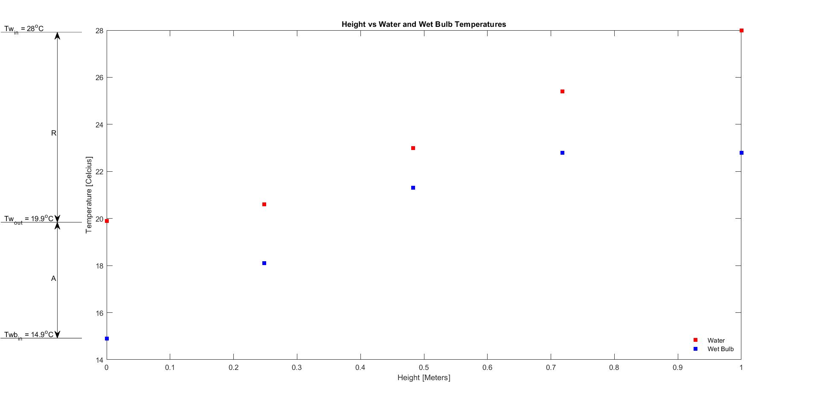

**Figure 1b.** Cooling tower efficiency as a function of water inlet flow rate.

**Figure 1c.** Specific humidity as a function of height along the cooling tower. The results for three different water inlet flow rates are shown.

**Figure 1d.** Dry bulb temperature as a function of height along the cooling tower. The results for three different water inlet flow rates are shown.

**Figure 1e.** Ratio of water outlet mass flow rate over water inlet mass flow rate as a function of water inlet temperature.

**Figure 1f.** Heat transfer rate to the dry air and the surroundings as a function of water inlet temperature.

Short-Answer Questions

**2a.** *Briefly describe what happens to the dry bulb temperature and the specific humidity of the air-water vapor mixture passing through the tower from point A (air inlet, water outlet) to point B (air outlet, water inlet). Explain the reason for these observations. Your response should consider the effect of evaporation. [4–6 sentences]*

Traveling from the bottom of the tower (air inlet, water outlet) to the top of the tower (air outlet, water inlet) the dry bulb temperature initially starts high, has a quick drop off at 0.248 meters and then gradually rises as the height of the tower increases. The specific humidity in the tower increases from the bottom of the tower to 0.718 meters and then slightly dips off at the outlet. This is the expected result where air entering the system will grab hold of moisture due to evaporation and the amount of water vapor in the air will continue to increase as the air grabs more moisture as it travels upwards. This will then increase the specific humidity inside the system where there will be more water vapor than dry air as the inlet air continues to grab moisture travelling upwards until the outlet where there is more access to dry air due to the opening and a small drop off in specific humidity occurs.

**2b.** *What percentage of the inlet water is evaporated? State how this percentage changes as the inlet water temperature increases. Provide a physical explanation for the observed trend. [2–4 sentences]*

For water inlet temperatures of 30.1℃, 28℃, and 26.8℃, the percentages of water evaporated are 2.99%, 2.11%, and 1.6% respecetively. The trend in the data shows that as initial inlet water temperature decreases, so does the amount of evoparated water. This is expected because when hotter water enters the system, its higher initial temperature vaporizes the dispersion of smaller water droplets easier leading to more evaporation. Essentially, the cooler inlet water temperature of 26.8℃ does not undergo the phase change from liquid to vapor as easily after dispersion of molecules as the 30.1℃ inlet water temperature does.

**2c.** *Based on your analysis of the data, what is the makeup water flow rate required (in g/s) for this facility? Your answer should be an average over the three experiments. State how close this average value is (in terms of a percentage) to what you observed during the experiments. [2 sentences]*

The average makeup water flow rate required for this facility would be 0.621 g/s. This average makeup value comes within 95.3%, 96.6%, and 1.1% of the actual makeup value for the 28 g/s, 20 g/s, and 40 g/s experiments.

**2d.** *State the maximum efficiency achieved (in %) over the measurement range investigated in the lab. Describe how efficiency varies with inlet water flow rate. [2 sentences]*

The maximum efficiency achieved in the lab was 70.78% efficient. As the water inlet flow rate increased, the efficiency of the cooling tower decreased.